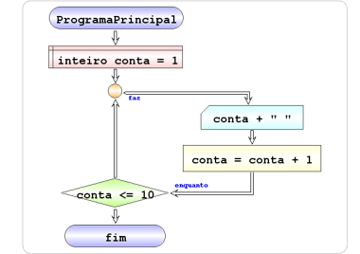Faz enquanto

start MainProgram

set int account = 1

do

write account + " "

run account = account + 1

while counting <= 10

end MainProgram